District Ventures Plants Seeds in Future
Through Investment in Just Vertical

Producers of indoor hydroponic sustainable food system to use capital to continue growth and innovation
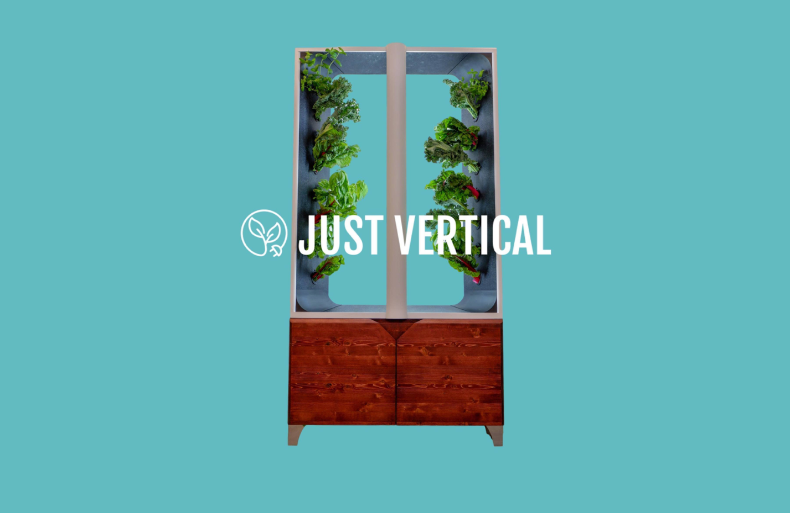
TORONTO, ON (October 19, 2021) – District Ventures Capital ("District Ventures") today announced the closing of an equity investment in Just Vertical, a Toronto-based company that produces vertical hydroponic growing systems which double as furniture.

Rooted in a mission to build sustainable food systems in cities, Just Vertical offers consumers the option of two indoor garden systems, The EVE and The AEVA, which take up only two square feet and can grow 10 pounds of produce a month. With the look of a mid-century-modern credenza and ability to grow up to 16 plants at once, Just Vertical products are in high-demand and currently back-ordered until mid Q4, 2021.

“With rising real estate prices and unfavourable winter temperatures, gardening is a cherished activity which can only be enjoyed by some for a portion of the year in Canada. Just Vertical is changing that and making urban farming more accessible with their innovative products,” said Arlene Dickinson, General Partner of District Ventures Capital. “The demand for sustainable and organic food continues to rise and the ability to grow one’s own produce year-round, inside a stylish piece of furniture, has definite mass appeal.”

Just Vertical’s garden towers require little maintenance, have no need for sunlight and fit easily in small spaces. The proudly Canadian company also offers over 200 seed pods, ranging from basil to strawberries to merlot lettuce, which grow under LED lights and automatic watering – using 95 per cent less water than conventional gardening.

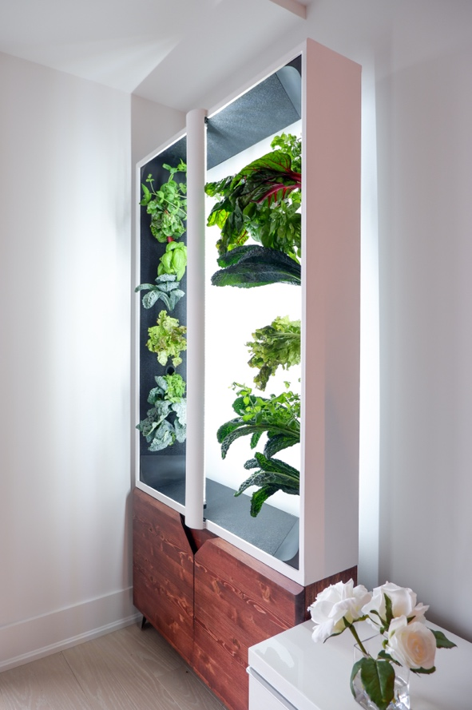
“It is a well-known fact that vertical farming is a revolutionary form of agriculture, yet there are very few products in the market for consumers to adopt this in their own homes. We are addressing that reality with Just Vertical’s line of products – which can fit into anyone’s lifestyle," said Kevin Jakiela, Co-founder of Just Vertical. “We are thrilled to partner with a Fund which understands the importance of sustainable food systems and look forward to working together to bring Just Vertical to more Canadians.”
It is estimated that the Earth has lost a third of arable land due to erosion or pollution in the past 40 years. Vertical farming and hydroponic growing systems, such as Just Vertical, address many of the shortcomings of traditional farming – specifically around sustainability and food quality.

–30–

Media Contact

PM Rendon
Director, Public Relations
District Ventures Capital
416-301-2391
pm@venturepark.ca

About District Ventures Capital

District Ventures Capital is a venture capital fund investing in innovative companies in the food & beverage and health & wellness sectors. The fund is led by General Partner, Arlene Dickinson. District Ventures is the leading ecosystem in Canada that focuses on the CPG space and brings capital, marketing support, programming, and commercialization as support to the companies it invests in.

For more information, visit www.districtventurescapital.com.

